CREATION OF NODE-RED

Our task to create node-red is successfully done. A screenshot of this node-red

screen is attached below:

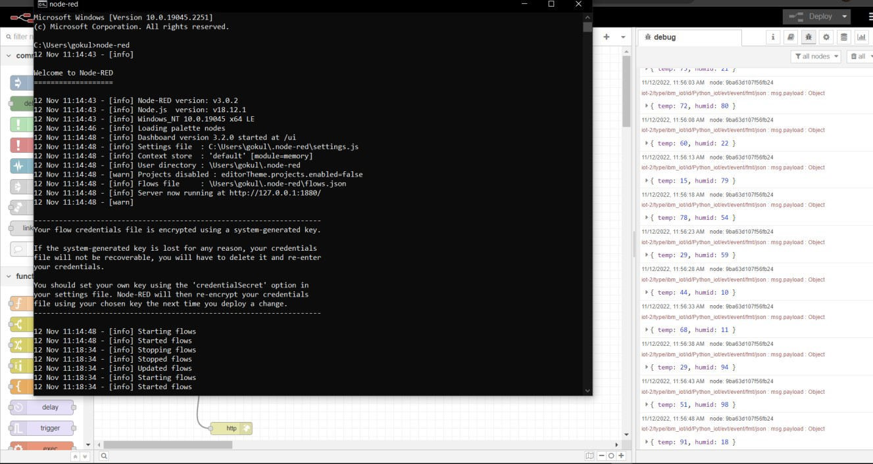

Date

16 November 2022

Team ID

PNT2022TMID15102

Project Name

Real – time River Water Quality Monitoring and Control System

Maximum Marks

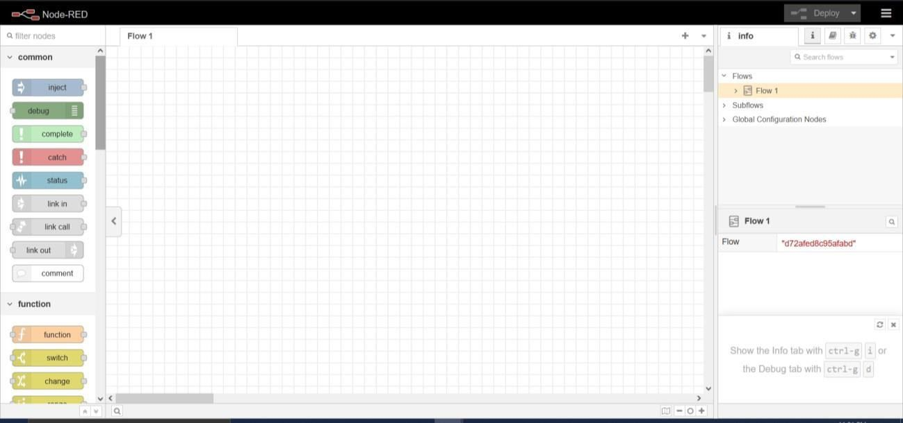

4 Marks

